# Q1.

Code:

#include <stdio.h>

int main() {

int age;

int citizen;

printf("Please enter your age: \n");

scanf("%d", &age);

printf("Are you a citizen of the state? 1: Yes, 0: No \n");

scanf("%d", &citizen);

if (age >= 18 && citizen == 1) {

printf("You are eligible to vote.\n");

} else {

printf("You are not eligible to vote.\n");

}

return 0;

}

Screenshots:

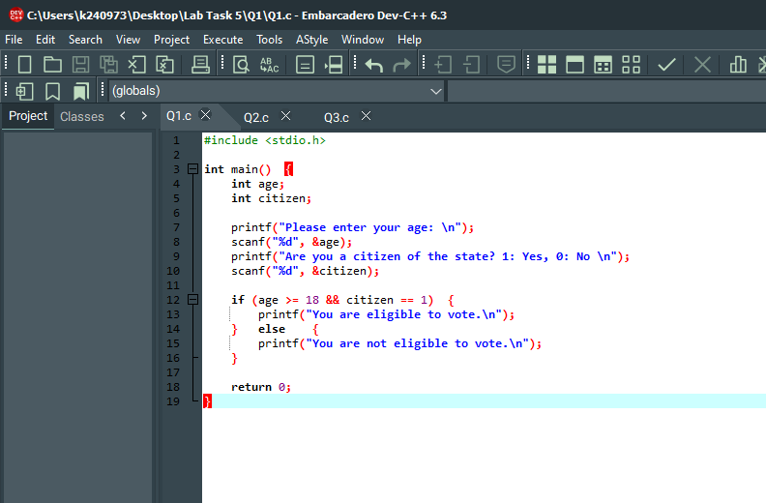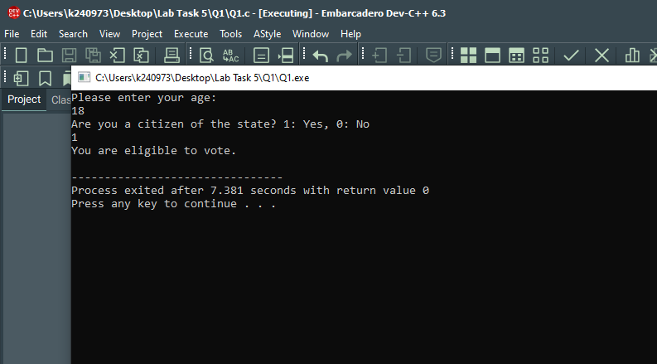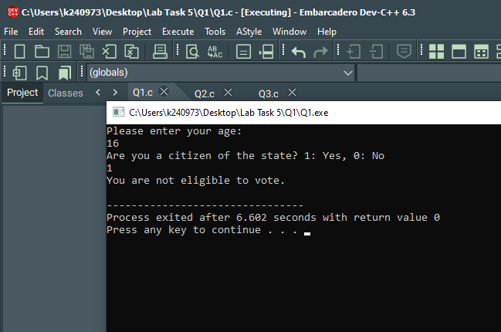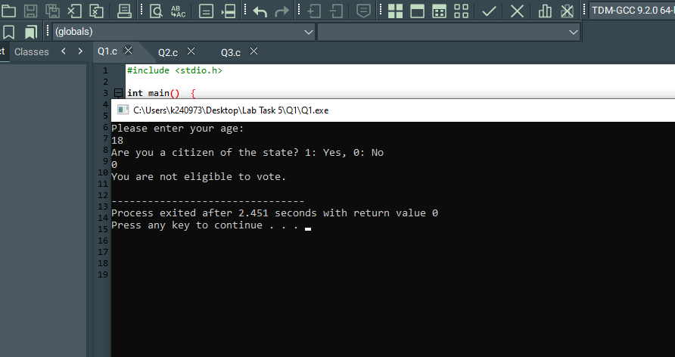

# Q2.

Code:

#include <stdio.h>

int main() {

int A, B, C;

printf("Enter first angle: \n");

scanf("%d", &A);

printf("Enter second angle: \n");

scanf("%d", &B);

printf("Enter third angle: \n");

scanf("%d", &C);

if (A + B + C == 180) {

printf("Triangle is valid\n");

} else {

printf("Triangle is invalid\n");

}

return 0;

}

Screenshots:

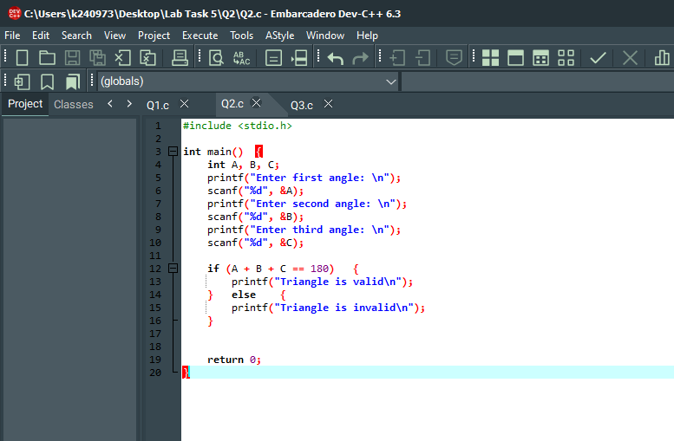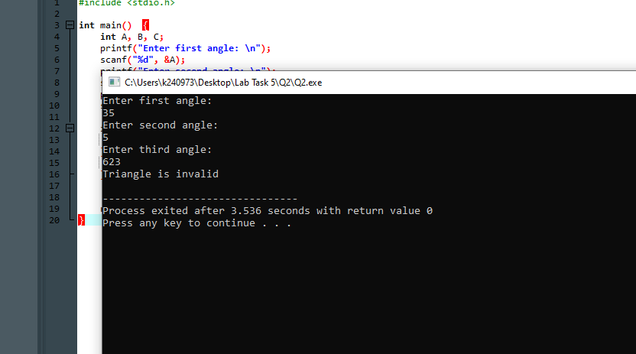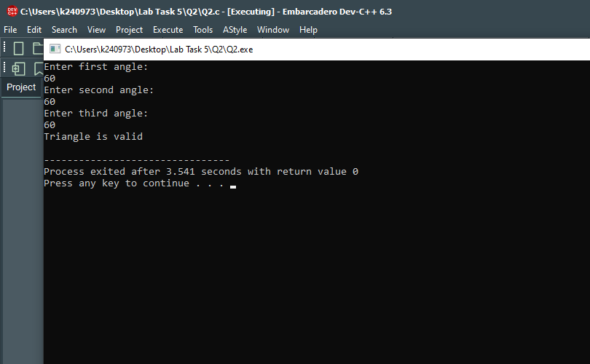

# Q3.

Code:

#include <stdio.h>

int main() {

int percent;

printf("Enter your percentage: \n");

scanf("%d", &percent);

(percent >= 90 && percent <= 100) ? printf("Grade: A") : printf("");

(percent >= 80 && percent <= 89) ? printf("Grade: B") : printf("");

(percent >= 70 && percent <= 79) ? printf("Grade: C") : printf("");

(percent >= 60 && percent <= 69) ? printf("Grade: D") : printf("");

(percent >= 0 && percent <= 59) ? printf("Grade: F") : printf("");

(percent < 0 || percent > 100) ? printf("Invalid Percentage") : printf("");

return 0;

}

Screenshots:

